Cloud formation-

CFT template creation –

Cft>> stacks >> create stack >> prepare template (template is ready)

>>specify tepalte (upload a tempalte file )>>next >> name of stack >>next >> tags >> next >> submit

Now update the existing cft

Cloud formation >> create stack >> demo >> update

File upload-

Need to know how to save yamal file and kuberneetes and aws code search

**Core part is resource**

**AWS cft template’s to create**

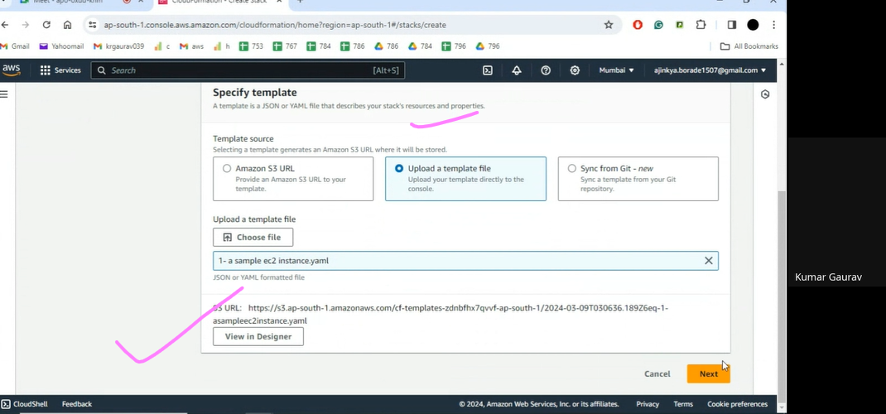

**Desired state**

